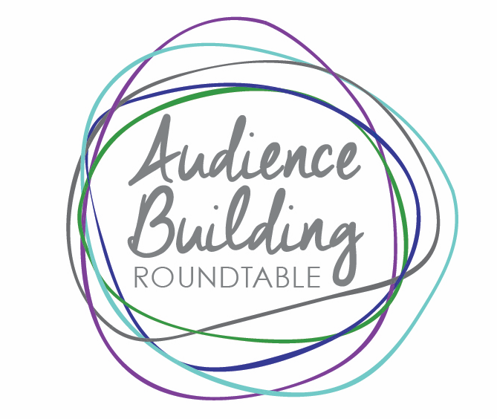
An Initiative of The Arthur M. Blank Family Foundation

2018 Audience Building Roundtable Program

Audience Building Roundtable Member Organizations are eligible for:

- Monthly Workshops / Peer Learning Sessions
- Consulting Support / Grants
- Large-Scale, Multi-Year Audience Building Innovation Project Grants
- Audience (Patron) Retention Study
- Blogs, Podcasts, Knowledgebase, Website as Resource
- PR/Media: support for pitching/coverage
- Audience Building Summit Participation

2018 Audience Building Roundtable Membership Requirements

Fulfillment of requirements results in eligibility to participate in all program elements listed above.

- Each member organization sets a goal for audience building for 2018.
  - Goals will be shared among the Roundtable’s membership to facilitate peer sharing and learning among organizations with similar goals. Goal sheets were completed at the 12/14/17 Roundtable meeting.

- At least one designated attendee from each member organization must attend 100% of the monthly meetings/workshops. The “designated attendee” can be the executive director or managing director, marketing lead staff person, or development lead staff person.
  - If the organization does not have a paid staff person, the volunteer executive director or a board member may fill the role of the designated attendee.
  - If the marketing or development staff person is the designated attendee, the executive director or managing director must attend at least 6 of the meetings throughout the year, including the summit.
  - A board member must attend at least 3 of the meetings throughout the year, including the summit.

- Each member organization will submit earned income and contributed income financial results to an outside evaluator/auditor selected by the Foundation. This information will include but may not be limited to the Form 990.

- Each member organization will submit a quarterly report (March 31, June 30, September 30, December 31.) A template will be provided. The report will ask for:
  - Audience retention data
    - This is required from the 10 organizations who have participated in a patron retention study
    - This is strongly encouraged for all other member organizations
  - Number of tickets sold for the prior quarter, if you are a ticket-selling entity
  - Revenue from ticket sales for the prior quarter, if you are ticket-selling entity
  - Number of individual donors for the prior quarter
  - Revenue from individual donors for the prior quarter
  - Organization chart with position titles for all paid staff
    - If no paid staff, submit your board org chart showing committee structure
  - (Brief) narrative description of the organization’s experience with at least one audience building strategy/experiment during the prior quarter

2018 Baseline Expectations of
Audience Building Roundtable Member Organizations

- Each member organization can identify its target audience(s)
- Each member organization collects audience data
- Each member organization deploys methods to attract new audience members
- Each member organization utilizes the patron ladder model to deepen relationships with audiences

